Develop a small java application which accepts employee id from the command prompt and display the details using arrays

import java.util.Scanner;

public class EmplyeeID {

public static void main(String args[])

{

Scanner sc=new Scanner(System.in);

int empid[]={101,102,103,104,105,106,107};

String empname[]={"Light","Ryuk","Lisa","Rem","Ryuzaki","Matsuda","Villan"};

String date[]={"01/05/2003","02/03/2004","01/02/2005","01/03/2006","01/09/2007","01/12/2009","02/05/2010"};

char code[]={'E','C','K','R','M','E','C'};

String dept[]={"CSE","ISE","ECE","EEE","AIML","AIDS","AE"};

double basic[]={20000,30000,10000,12000,50000,23000,29000};

double HRA[]={8000,12000,8000,6000,20000,9000,12000};

double IT[]={3000,9000,1000,2000,20000,4400,10000};

char desigcode[]={'e','c','k','r','m'};

String designation[]={"Engineer","Consultant","Clerk","Receptionist","Manager"};

double DA[]={20000,32000,12000,15000,40000};

System.out.print("Enter employee id");

int id=sc.nextInt();

int flag=0;

double salary=0;

for(int i=0;i<empid.length;i++)

{

if(id==empid[i])

{

flag=1;

System.out.print("Emp id:"+empid[i]);

System.out.print("Employee name :"+empname[i]);

System.out.print("Department "+dept[i]);

switch(code[i])

{

case 'E': System.out.print("Designation : Engineer");

System.out.print("DA : 20000");

salary=basic[i]+HRA[i]+20000-IT[i];

System.out.print("The salary is "+salary);

break;

case 'C':System.out.print("Designation : Consultant");

System.out.print("DA : 32000");

salary=basic[i]+HRA[i]+32000-IT[i];

System.out.print("The salary is "+salary);

break;

case 'K':System.out.print("Designation : Clerk");

System.out.print("DA : 12000");

salary=basic[i]+HRA[i]+12000-IT[i];

System.out.print("The salary is "+salary);

break;

case 'R':System.out.print("Designation : Receptionist");

System.out.print("DA : 15000");

salary=basic[i]+HRA[i]+15000-IT[i];

System.out.print("The salary is "+salary);

break;

case 'M':System.out.print("Designation : Manager");

System.out.print("DA : 40000");

salary=basic[i]+HRA[i]+40000-IT[i];

System.out.print("The salary is "+salary);

break;

}

}

}

if(flag==0)

{

System.out.print("Employee details not found !!");

}

}

}

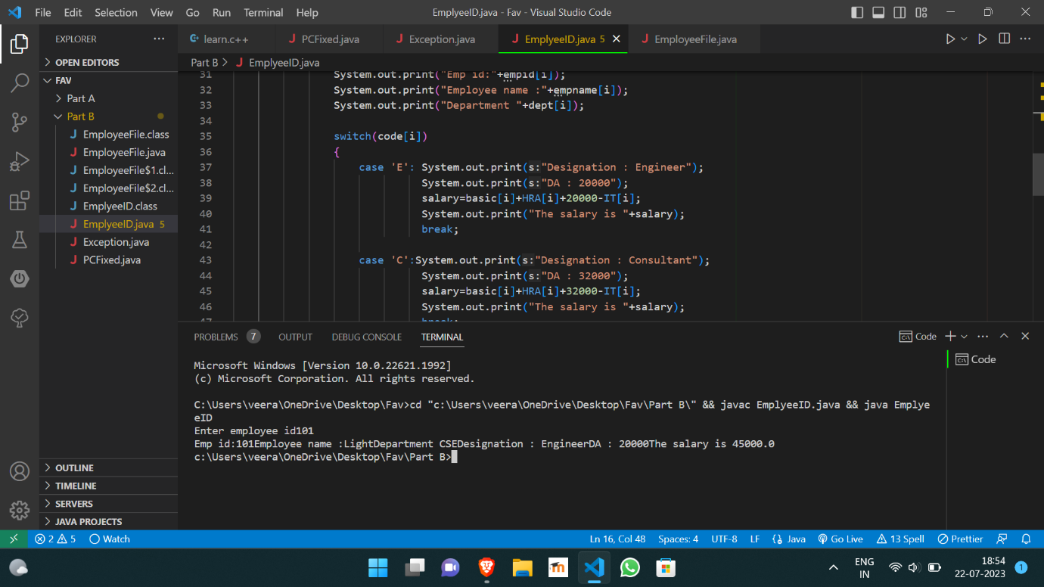

https://github.com/Veeragoutham04/Java_Lab/blob/main/Employee_ID